HTML TO-DO LIST

MAJOR PROJECT

**INTERNSHIP PROJECT – HTML TO-DO LIST**

**TASK : CREATE A TO-DO LIST USING HTML PROGRAMMING LANGUAGE**

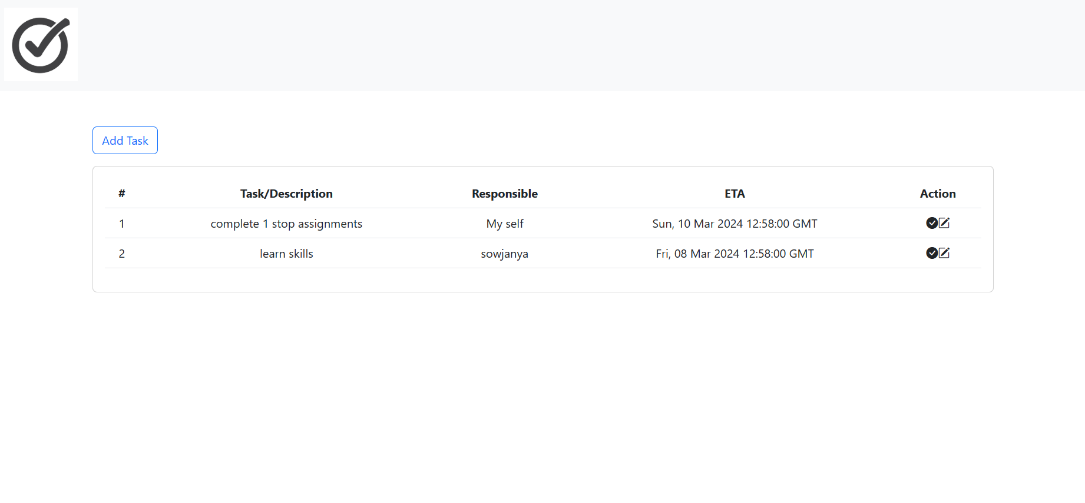

**ABSTRACT :**

The To-Do List project is a comprehensive web application aimed at streamlining task management processes. Utilizing HTML for structural markup, Bootstrap for aesthetic enhancements, and JavaScript for interactive features, the project offers users a seamless experience for organizing tasks. The inclusion of modal windows optimizes task entry and editing workflows, enhancing user productivity. By integrating local storage capabilities, the application ensures that task data persists between browsing sessions, fostering continuity and convenience for users. Additionally, the integration of icons from Bootstrap and Font Awesome not only enhances visual appeal but also improves usability by providing intuitive visual cues. Overall, the To-Do List project represents a sophisticated yet user-friendly solution for effective task management in both personal and professional contexts.

Furthermore, the To-Do List project demonstrates a commitment to accessibility and responsiveness, ensuring compatibility across various devices and screen sizes. The use of Bootstrap's responsive grid system and components enables the application to adapt fluidly to different viewport dimensions, providing a consistent user experience across desktops, tablets, and smartphones. This responsiveness enhances usability and convenience, allowing users to manage their tasks seamlessly regardless of the device they are using. Moreover, the project's clean and well-structured codebase promotes maintainability and scalability, making it easy to extend functionality or customize the interface in the future. By combining robust functionality with a user-centric design approach, the To-Do List project stands as a versatile and reliable tool for individuals and teams seeking to streamline their task management workflows effectively.

In addition to its core functionalities, the To-Do List project prioritizes user experience by implementing intuitive and accessible design principles. The user interface (UI) features clear and concise labeling, ensuring that users can easily understand the purpose and function of each element. Furthermore, the use of modal windows for task entry and editing reduces cognitive load by providing focused interactions within a contained environment. This design choice enhances usability by guiding users through the task management process step by step, minimizing confusion and errors. Additionally, the application incorporates keyboard accessibility and semantic HTML markup, enabling users with disabilities to navigate and interact with the interface effectively. By embracing inclusivity and usability best practices, the To-Do List project strives to accommodate diverse user needs and preferences, fostering a positive and inclusive user experience for all.

Moreover, the To-Do List project embraces continuous improvement and adaptation through its modular and extensible architecture. By leveraging the latest web technologies and development practices, the application remains agile and responsive to evolving user requirements and industry trends. Regular updates and enhancements ensure that the project stays relevant and competitive in a rapidly changing digital landscape. Furthermore, the project fosters community engagement and collaboration through open-source contributions and feedback mechanisms. Users and developers alike can contribute to the project's evolution by reporting bugs, suggesting features, or submitting code contributions. This collaborative approach not only enriches the project's functionality but also cultivates a sense of ownership and belonging within the user community. As a result, the To-Do List project continues to evolve and thrive as a dynamic and resilient solution for modern task management needs.

**OBJECTIVE :**

The objective of this project is to implement a functional To-Do List web application with the following features :

**User Interface (UI) :**

- The UI is designed using HTML and Bootstrap framework to ensure responsiveness and modern styling.

- It includes a navigation bar with a logo and a button to add tasks.

- Task information is displayed in a table format with columns for task number, description, responsible person, ETA, and action buttons.

**Add Task Functionality :**

- Users can click on the "Add Task" button to open a modal window.

- In the modal window, users can input details such as task description, responsible person, and ETA (estimated time of arrival).

- Upon submission, the task details are stored in the browser's local storage using JavaScript.

**View Tasks :**

- Upon loading the page, tasks stored in the local storage are retrieved and displayed in the table format.

- Each task includes its corresponding details, such as description, responsible person, and ETA.

- If no tasks are stored, a message indicating that no tasks have been added yet is displayed.

**Edit Task Functionality :**

- Users can click on the edit button (pencil icon) next to a task to edit its details.

- Editing opens a modal window pre-populated with the task's current details.

- Users can modify the task description, responsible person, and ETA.

- Upon submission, the edited task details are updated in the local storage.

**Mark Task as Done :**

- Users can click on the checkmark icon next to a task to mark it as done.

- This action removes the task from the list.

- The updated task list is then stored in the local storage.

**Data Persistence :**

- Tasks added, edited, or marked as done are stored in the browser's local storage.

- This ensures that the tasks persist even if the user refreshes the page or closes the browser.

**Modal Windows :**

- Modal windows are used for both adding and editing tasks to provide a clean and focused user interface.

- They include form inputs for capturing task details and buttons for submission and cancellation.

**SIGNIFICANCE :**

This project is a simple web-based To-Do List application built using HTML, CSS (Bootstrap), and JavaScript. Here's a breakdown of its significance and key components:

**User Interface (UI) :** The project provides a clean and intuitive UI design using Bootstrap CSS framework. Bootstrap simplifies the process of creating responsive and mobile-first websites.

**Functionality :**

- Add Task : Users can add tasks by clicking on the "Add Task" button, which triggers a modal form where they can input task details such as description, responsible party, and ETA (Estimated Time of Arrival).

- Display Tasks : Tasks are displayed in a table format showing their description, responsible party, ETA, and action buttons.

- Edit Task : Users can edit existing tasks by clicking on the edit icon, which opens a modal form pre-filled with the task details for editing.

- Delete Task : Tasks can be marked as done, removing them from the list.

- LocalStorage : The application uses localStorage to persist task data locally in the user's browser, enabling the retention of tasks even after the page is refreshed or closed.

**Modularity :** The code is structured into separate functions for adding tasks, editing tasks, marking tasks as done, and updating the task list displayed on the UI. This modular approach enhances code readability, maintainability, and scalability.

**Interactivity :** JavaScript is used to add interactivity to the application. Event listeners are attached to various elements such as buttons and icons to trigger specific actions like showing modals, adding or updating tasks, etc.

**Error Handling :**  Although not extensively implemented, error handling could be improved in cases such as validating user input, handling edge cases, and providing meaningful error messages to enhance the user experience.

**KEY FEATURES :**

The key features of this project are :

**Bootstrap Framework :** Utilizes Bootstrap for styling and layout components, ensuring a responsive and visually appealing design.

**Add Task Modal :** Provides a modal window for users to add new tasks. It includes input fields for task description, responsible person, and estimated time of arrival (ETA).

**Display Tasks in Table :** Displays added tasks in a table format. Each task row includes columns for task number, description, responsible person, ETA, and actions.

**Edit Task Modal :** Allows users to edit existing tasks. Clicking on the edit icon opens a modal window with pre-filled fields for editing the task details.

**Mark Task as Done :** Enables users to mark tasks as done. Clicking on the checkmark icon removes the task from the list.

**Local Storage :** Utilizes local storage to persist task data even after refreshing or closing the browser. This ensures that tasks are saved and accessible across sessions.

**Dynamic HTML Generation :** Generates HTML dynamically based on the task data retrieved from local storage. This ensures that the task list is always up to date and reflects any changes made by the user.

**Responsive Design :** Utilizes Bootstrap's grid system to ensure the application is responsive and works well across different screen sizes and devices.

By combining these features, the To-Do List application provides users with a simple yet effective tool for managing their tasks, with the ability to add, edit, and mark tasks as done while ensuring data persistence through local storage.

**PROJECT COMPONENTS :**

**HTML Structure** : The foundation of the project lies in its HTML structure, which defines the layout and components of the application. Structured and semantic HTML ensures clarity and accessibility, creating a foundation upon which the project's functionality is built.

**Bootstrap Styling :** To enhance the user experience, Bootstrap, a popular front-end framework, is integrated for styling and responsiveness. This ensures a consistent and visually pleasing design across various devices, from desktops to smartphones.

**JavaScript Functionality :** The dynamic functionality of the To-Do List is achieved through JavaScript. This scripting language facilitates real-time interactions, allowing users to add tasks, mark them as done, edit details, and view their entire task list seamlessly.

**Modals for User Interaction :** The inclusion of modals optimizes user interaction. Modal forms enable users to add new tasks and edit existing ones with minimal disruption to the overall user experience. This design choice prioritizes a clean and focused interface.

**Local Storage Integration :** To ensure data persistence, the project leverages local storage. Users can access their task lists consistently across sessions, providing a seamless experience without the need for account creation or external databases.

**Icon Integration :** Icons from Bootstrap Icons and Font Awesome are strategically incorporated to improve visual elements and provide intuitive cues for users. Icons contribute to a user-friendly design, making it easier for individuals to comprehend and navigate the application.

**PROJECT STRUCTURE :**

**HTML Structure :**

* <!DOCTYPE html> : Declares the HTML version and language.
* <head> : Contains meta-information, CSS links for styling, and script links for JavaScript.
* <body> : The main content of the webpage, including navigation, buttons, tables, and modals.

1. **Bootstrap and Icons**

* Bootstrap is utilized for styling and responsiveness.
* Icons from Bootstrap Icons and Font Awesome are used for better user interface elements.

1. **Navigation Bar**

* A simple navigation bar is included with a logo and a responsive button for menu options.

1. **Task Table**

* A table structure is used to display tasks, with columns for task details and action buttons.

1. **Modals**

* Two modals are used for adding tasks (addtaskmodal) and updating tasks (updatetaskmodal).
* The modals include forms with fields for task description, responsible person, and ETA.

1. **JavaScript**

* JavaScript functions handle the logic for adding tasks, creating HTML from stored tasks, marking tasks as done, editing tasks, and updating tasks.

**INTRODUCTION :**

In a world where distractions abound and time is a precious commodity, effective task management is essential for maximizing productivity and achieving goals. The To-Do List project acknowledges the challenges individuals face in balancing their responsibilities and endeavors to provide a solution that simplifies task organization. By leveraging modern web technologies and design principles, this project aims to empower users to take control of their schedules and prioritize tasks effectively.

One of the key features of the To-Do List project is its user-centric approach. From the intuitive user interface to the seamless task creation and editing capabilities, every aspect of the application is designed with the user's experience in mind. By minimizing complexity and focusing on usability, the project strives to make task management accessible to users of all backgrounds and skill levels. Whether managing personal errands, work projects, or collaborative tasks, users can rely on the To-Do List to streamline their workflow and enhance productivity.

Moreover, the To-Do List project recognizes the importance of adaptability in today's dynamic environment. With its responsive design and cross-device compatibility, the application ensures that users can access their tasks anytime, anywhere, and from any device. Whether on a desktop computer, laptop, tablet, or smartphone, users can rely on the To-Do List to keep their tasks organized and stay on top of their commitments. This flexibility enables users to seamlessly transition between different devices and environments without sacrificing productivity.

In conclusion, the To-Do List project represents a modern and versatile solution for managing tasks in today's fast-paced world. By combining user-friendly design with powerful functionality, the project empowers individuals to take charge of their schedules and accomplish more with less effort. Whether used for personal task management or collaborative project coordination, the To-Do List offers a reliable and efficient tool for organizing activities, prioritizing responsibilities, and achieving success in both personal and professional endeavors.

**REQUIREMENT ANALYSIS :**

1. **Functional Requirements:**

**Task Management:**

Add Task : Users should be able to add new tasks to the list.

Each task should include a description, responsible person, and ETA (Estimated Time of Arrival).

Edit Task : Users should be able to edit existing tasks to update details such as description, responsible person, and ETA.

Mark Task as Done : Users should be able to mark tasks as completed.

Completed tasks should be visually distinguished from active tasks and optionally removed from the list.

**User Interface :**

Navigation : The application should have a navigation bar for easy access to different functionalities.

The navigation bar should include a logo or branding element.

Task List : Tasks should be displayed in a clear and organized manner, preferably in a table format.

Each task should display its description, responsible person, ETA, and action buttons for editing and marking as done.

Modals : Modal dialogs should be used for adding and editing tasks to provide a focused and clutter-free user experience.

**Persistence :**

Local Storage : Tasks should be stored locally on the user's browser using LocalStorage or a similar mechanism.

Local storage should enable data persistence across sessions, allowing users to access their tasks even after closing and reopening the application.

1. **Non-Functional Requirements :**

**Usability :**

Intuitive Interface : The user interface should be intuitive and easy to navigate, even for users with minimal technical expertise.

Responsive Design : The application should be responsive and display properly on a variety of devices and screen sizes, including desktops, tablets, and smartphones.

**Performance:**

Efficient Operations : Operations such as adding, editing, and deleting tasks should be performed efficiently, with minimal latency.

Optimized Rendering : The application should render quickly, even when dealing with large numbers of tasks.

**Security :**

Data Privacy : User’s task data should be stored securely and privately, accessible only to the user who created them.

Protection Against XSS : The application should guard against cross-site scripting (XSS) attacks by sanitizing user inputs and properly encoding outputs.

**CODE :**

<!DOCTYPE html>

<html lang="en">

<head>

    <meta charset="utf-8">

    <link href="https://cdn.jsdelivr.net/npm/bootstrap@5.3.0-alpha3/dist/css/bootstrap.min.css" rel="stylesheet" integrity="sha384-KK94CHFLLe+nY2dmCWGMq91rCGa5gtU4mk92HdvYe+M/SXH301p5ILy+dN9+nJOZ" crossorigin="anonymous">

    <link rel="stylesheet" href="https://cdn.jsdelivr.net/npm/bootstrap-icons@1.10.2/font/bootstrap-icons.css" integrity="sha384-b6lVK+yci+bfDmaY1u0zE8YYJt0TZxLEAFyYSLHId4xoVvsrQu3INevFKo+Xir8e" crossorigin="anonymous">

    <link rel="stylesheet" href="https://cdn.jsdelivr.net/npm/@fortawesome/fontawesome-free@6.2.1/css/fontawesome.min.css" integrity="sha384-QYIZto+st3yW+o8+5OHfT6S482Zsvz2WfOzpFSXMF9zqeLcFV0/wlZpMtyFcZALm" crossorigin="anonymous">

    <title>TO-DO LIST</title>

</head>

<body>

    <script src="https://code.jquery.com/jquery-3.2.1.slim.min.js"

        integrity="sha384-KJ3o2DKtIkvYIK3UENzmM7KCkRr/rE9/Qpg6aAZGJwFDMVNA/GpGFF93hXpG5KkN"

        crossorigin="anonymous"></script>

    <script src="https://cdn.jsdelivr.net/npm/popper.js@1.12.9/dist/umd/popper.min.js"

        integrity="sha384-ApNbgh9B+Y1QKtv3Rn7W3mgPxhU9K/ScQsAP7hUibX39j7fakFPskvXusvfa0b4Q"

        crossorigin="anonymous"></script>

    <script src="https://cdn.jsdelivr.net/npm/bootstrap@4.0.0/dist/js/bootstrap.min.js"

        integrity="sha384-JZR6Spejh4U02d8jOt6vLEHfe/JQGiRRSQQxSfFWpi1MquVdAyjUar5+76PVCmYl"

        crossorigin="anonymous"></script>

    <nav class="navbar navbar-expand-lg navbar-light bg-light">

        <div class="container-fluid">

            <a href="#" class="navbar-brand">

                <img src="C:\Users\rajit\OneDrive\Desktop\FRONTEND_MINOR_PROJECT\assests\logoo.jpg" alt="logo" width="100"></a>

            <button class="navbar-toggler" data-bs-toggle="collapse" data-bs-target="navbar">

                <i class="bi bi-list"></i>

            </button>

            <div class="collapse navbar-collapse" id="navbar">

                <div class="navbar-nav ms-auto"></div>

            </div>

        </div>

    </nav>

    <div class="container p-5">

        <div class="mb-3">

            <button type="button" class="btn btn-outline-primary" onclick="showaddtaskmodal()">Add Task</button>

        </div>

        <div class="d-flex justify-content-center">

            <div class="col-sm-12 col-md-12 col-lg-12">

                <div class="card">

                    <div class="card-body">

                        <table class="table">

                            <thead class="text-center">

                                <th>#</th>

                                <th>Task/Description</th>

                                <th>Responsible</th>

                                <th>ETA</th>

                                <th>Action</th>

                            </thead>

                            <tbody class="text-center" id="tasktablebody">

                            </tbody>

                        </table>

                    </div>

                </div>

            </div>

        </div>

    </div>

    <div class="modal fade" id="addtaskmodal" data-bs-backdrop="static" data-bs-keyboard="false" tabindex="1"

        aria-labelledby="addtaskmodallabel1" aria-hidden="true">

        <form id="inputform">

            <div class="modal-dialog">

                <div class="modal-content">

                    <div class="modal-header">

                        <h4 class="modal-title" id="addtaskmodallabel1">Add task</h4>

                        <button type="button" class="btn-close" data-bs-dismiss="modal" aria-label="close"></button>

                    </div>

                    <div class="modal-body">

                        <div class="form-group">

                            <label for="addtasktextarea" class="col-form-label">Task/description</label>

                            <textarea class="form-control" name="Task/description" rows="3" id="addtasktextarea"

                                placeholder="add your description"></textarea>

                        </div>

                        <div class="form-group">

                            <label for="addresponce" class="col-form-label">Responsible</label>

                            <input type="text" class="form-control" name="responce" id="addresponce">

                        </div>

                        <div class="form-group">

                            <label for="addeta" class="col-form-label">ETA</label>

                            <input type="datetime-local" class="form-control" name="eta" id="addeta">

                        </div>

                    </div>

                    <div class="modal-footer">

                        <button type="button" class="btn btn-secondary" data-bs-dismiss="modal">cancel</button>

                        <button type="button" class="btn btn-primary" onclick="addtask()">Add task</button>

                    </div>

                </div>

            </div>

        </form>

    </div>

    <div class="modal fade" id="updatetaskmodal" data-bs-backdrop="static" data-bs-keyboard="false" tabindex="1"

        aria-labelledby="edittaskmodallabel1" aria-hidden="true">

        <form id="updateform">

            <div class="modal-dialog">

                <div class="modal-content">

                    <div class="modal-header">

                        <h4 class="modal-title" id="updatetaskmodallabel1">edit task</h4>

                        <button type="button" class="btn-close" data-bs-dismiss="modal" aria-label="close"></button>

                    </div>

                    <div class="modal-body">

                        <div class="form-group">

                            <label for="edittasktextarea" class="col-form-label">Task/description</label>

                            <textarea class="form-control" name="Task/description" rows="3" id="edittasktextarea"

                                placeholder="add your description"></textarea>

                        </div>

                        <div class="form-group">

                            <label for="editresponce" class="col-form-label">Responsible</label>

                            <input type="text" class="form-control" name="responce" id="editresponce">

                        </div>

                        <div class="form-group">

                            <label for="editeta" class="col-form-label">ETA</label>

                            <input type="datetime-local" class="form-control" name="eta" id="editeta">

                        </div>

                        <input type="hidden" id="editindex" name="taskindex">

                    </div>

                    <div class="modal-footer">

                        <button type="button" class="btn btn-secondary" data-bs-dismiss="modal">cancel</button>

                        <button type="button" class="btn btn-primary" onclick="updatetask()">update task</button>

                    </div>

                </div>

            </div>

        </form>

    </div>

    <script src="https://cdn.jsdelivr.net/npm/bootstrap@5.3.0-alpha3/dist/js/bootstrap.bundle.min.js"

        integrity="sha384-ENjdO4Dr2bkBIFxQpeoTz1HIcje39Wm4jDKdf19U8gI4ddQ3GYNS7NTKfAdVQSZe"

        crossorigin="anonymous"></script>

    <script>

        createhtmlfromstorage();

        function showaddtaskmodal() {

            $("#addtaskmodal").modal("show");

        }

        function addtask() {

            console.log("Add task clicked");

            $("#addtaskmodal").modal("hide");

            var dataarr = $("#inputform").serializeArray();

            var taskObject = new Object();

            var storageObjectArr = [];

            var storageObject = localStorage.getItem("newstorage");

            for (var i in dataarr) {

                var name = dataarr[i]['name']

                var value = dataarr[i]['value']

                taskObject[name] = value

            }

            if (storageObject != null && storageObject != undefined && storageObject != "") {

                storageObjectArr = JSON.parse(storageObject)

                storageObjectArr.push(taskObject)

            }

            else {

                storageObjectArr.push(taskObject)

            }

            localStorage.setItem("newstorage", JSON.stringify(storageObjectArr))

            createhtmlfromstorage();

            $("#inputform").trigger('reset')

        }

        function createhtmlfromstorage() {

            var storageObjectArr = [];

            var storageObject = localStorage.getItem("newstorage");

            var storageObjectArr = JSON.parse(storageObject);

            var html = "";

            console.log(storageObjectArr)

            if (storageObject != null && storageObject != undefined && storageObject != "") {

                if (storageObjectArr && storageObjectArr.length > 0) {

                    for (let i in storageObjectArr) {

                        var date = new Date(storageObjectArr[i]['eta'])

                        html = html + '<tr>'

                            + '<td>' + (parseInt(i) + 1) + '</td>' +

                            '<td>' + storageObjectArr[i]['Task/description'] + '</td>' +

                            ' <td>' + storageObjectArr[i]['responce'] + '</td>' +

                            '<td>' + date.toUTCString() + '</td>' +

                            '<td><i class="bi bi-check-circle-fill" onclick="markasdone(' + i + ')"></i><i class="bi bi-pencil-square" onclick="edittask(' + i + ')"></i></td></tr>'

                    }

                }

                else {

                    html = '<tr><td colspan="5">No tasks added yet</td></tr>'

                }

            }

            $("#tasktablebody").html(html);

        }

        function markasdone(index) {

            console.log(index)

            var storageObjectArr = [];

            var storageObject = localStorage.getItem('newstorage')

            if (storageObject != null && storageObject != undefined && storageObject != "") {

                storageObjectArr = JSON.parse(storageObject);

                storageObjectArr.pop(index)

            }

            localStorage.setItem("newstorage", JSON.stringify(storageObjectArr))

            createhtmlfromstorage()

        }

        function edittask(index) {

            var storageObjectArr = [];

            var storageObject = localStorage.getItem('newstorage')

            if (storageObject != null && storageObject != undefined && storageObject != "") {

                storageObjectArr = JSON.parse(storageObject);

                $("#editeta").val(storageObjectArr[index]['Task/description'])

                $("#editresponce").val(storageObjectArr[index]['responce'] )

                $("#edittasktextarea").val(storageObjectArr[index]['eta'])

                $("#editindex").val(index)

                $("#updatetaskmodal").modal("show")

            }

        }

        function updatetask()

        {

            $("#updatetaskmodal").modal("hide")

            var dataarr = $("#updateform").serializeArray();

            var taskObject = new Object();

            var storageObjectArr = [];

            var storageObject = localStorage.getItem("newstorage");

            for (var i in dataarr) {

                var name = dataarr[i]['name']

                var value = dataarr[i]['value']

                taskObject[name] = value

            }

            if (storageObject != null && storageObject != undefined && storageObject != "") {

                storageObjectArr = JSON.parse(storageObject)

                storageObjectArr[taskObject['taskindex']]=taskObject

            }

            localStorage.setItem("newstorage", JSON.stringify(storageObjectArr))

            createhtmlfromstorage()

        }

    </script>

</body>

</html>

Functionality and the elements of this project :

**Functionality :**

Add Task Button : Opens a modal to add a new task.

Task Table : Displays tasks with their descriptions, responsible person, ETA (Estimated Time of Arrival), and action buttons.

Action Buttons :

- Check Circle Icon : Marks the task as done.

- Pencil Square Icon : Allows editing of the task.

**Display :**

- Navbar with a logo.

- "Add Task" Button.

- Task table with columns: #

- Task/Description

- Responsible

- ETA

- Action

**JavaScript and Event Handling :**

“showaddtaskmodal()” : Function to show the add task modal when "Add Task" button is clicked.

“addtask()” : Function to add a new task to local storage, then update the display with the new task.

“createhtmlfromstorage()” : Function to create HTML for displaying tasks from local storage.

“markasdone(index)” : Function to mark a task as done and update the display.

“edittask(index)” : Function to populate the edit task modal with task details for editing.

“updatetask()” : Function to update the task details and refresh the display.

**Display Updates :**

- Adding a new task updates the task table display.

- Marking a task as done updates the task table display.

- Editing a task updates the task table display.

**Functionality of Buttons :**

Add Task Button : Opens a modal to input task details.

Cancel Button in Modals : Closes the respective modal.

Add Task Button in Add Task Modal : Adds the task to the list.

Update Task Button in Edit Task Modal : Updates the task details.

Check Circle Icon in Task Table : Marks the task as done.

Pencil Square Icon in Task Table : Allows editing of the task.

**USAGE :**

1. Click the "Add Task" button to open the "Add Task" modal.
2. Enter task details in the modal form and click "Add Task."
3. View and manage tasks in the table.
4. Mark tasks as done or edit them using the action buttons.
5. The updated task list is stored in the local storage for persistence.

**OUTPUTS :**



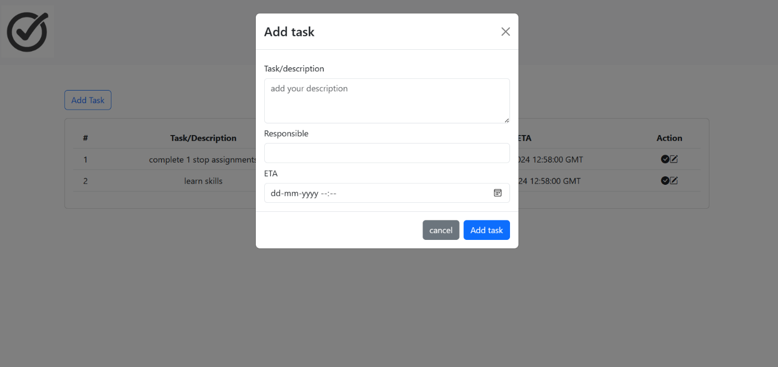

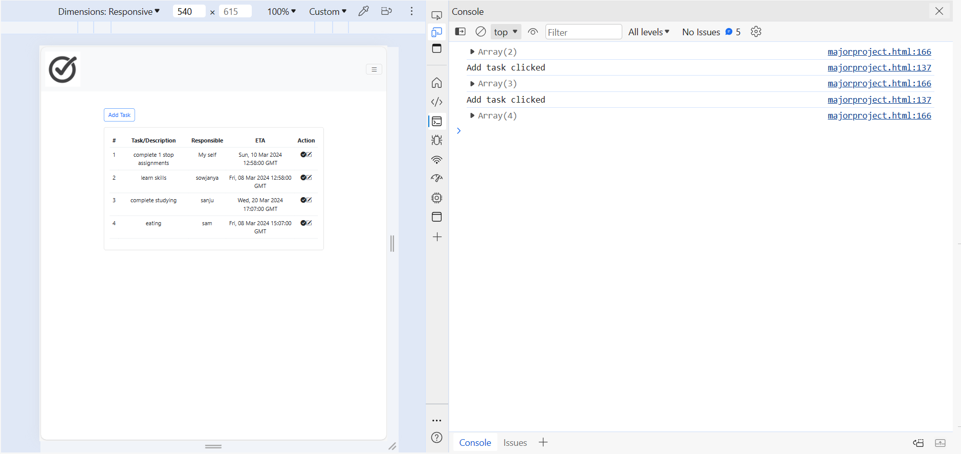

**CONCLUSION :**

The To-Do List project represents a significant stride in addressing the evolving needs of individuals grappling with the complexities of modern life. With its user-centric design, the project offers a practical and efficient solution for task management, leveraging the synergy of HTML, Bootstrap, and JavaScript to create a seamless and intuitive user experience.

1. **User Empowerment through Task Management :** In the pursuit of personal and professional success, effective task management is paramount. The To-Do List project empowers users by providing a centralized and accessible platform to organize their tasks, fostering a sense of control and clarity in the face of diverse responsibilities.
2. **Responsive and Visually Appealing Design :** The integration of Bootstrap ensures a responsive design, adapting gracefully to various devices and screen sizes. This responsiveness, coupled with carefully chosen icons from Bootstrap Icons and Font Awesome, contributes to a visually appealing and user-friendly interface. The project recognizes the importance of aesthetics in enhancing user engagement and satisfaction.
3. **Seamless User Interaction :** The utilization of modals for task entry and editing exemplifies the project's commitment to seamless user interaction. By minimizing disruptions and maintaining focus, the modals contribute to an efficient and enjoyable user experience. Users can effortlessly add, edit, and manage tasks without navigating away from the main interface.
4. **Data Persistence for Consistent Access :** The incorporation of local storage as a data storage solution ensures that users can access their task lists consistently across different sessions. This feature adds a layer of convenience, eliminating the need for account creation or reliance on external databases. Users can rely on the To-Do List as a dependable companion for managing their tasks over time.
5. **Future Enhancements and Continuous Improvement :** As with any digital solution, the To-Do List project remains open to future enhancements and continuous improvement. User feedback will play a crucial role in identifying areas for refinement and additional features. The project's modular development approach facilitates scalability, making it adaptable to evolving user requirements.

In conclusion, the To-Do List project stands as a testament to the synergy of technology and user-centric design, providing a valuable tool for individuals seeking to enhance their task management capabilities. Whether used for professional endeavors, academic pursuits, or personal growth, the project strives to contribute positively to the lives of its users, promoting productivity and efficiency in the face of today's dynamic challenges.